- Pick any one feature from a popular app you use (for example, 'Add to Cart' in Flipkart or 'Send Message' in WhatsApp) and write 5 high-level test scenarios for it. List each scenario clearly.
Ans=> whatsapp
- Verify successful message sending or not.
- Verify message sending without an internet connection.
- Verify sending different types of messages.
- Verify message delivery and read status. sent, delivered, and read
- Verify message sending to different chat types as individual chats, group chats, and to contacts.

- For the 'Search Restaurant' feature in a Zomato-like app, write 10 specific test scenarios covering both functional and non-functional aspects.<br><br><em><strong>Hint:</strong> Think about different search inputs, filters, empty results, speed, and UI behavior.</em>
Ans =>
- Verify the user can search for a restaurant using a valid restaurant name.

- Verify restaurants are displayed when searching with a partial restaurant name.

- Verify appropriate message is displayed when no restaurants match the search keyword.

- Verify the search works correctly with special characters, numbers, and different letter cases.

- Verify that search results are updated correctly when filters such as rating, price, or delivery time.

- Verify the search results are cleared or reset when the search box is cleared.

- Verify the application displays search results within an acceptable response time.

- Verify the search feature remains responsive and performs well even when many users search.
- Verify that the search bar and search results are displayed properly on different screen sizes and device.

- Verify the application handles network by displaying an appropriate error message or retry option during search.

- Choose one scenario from your Zomato 'Search Restaurant' scenarios and convert it into 5 detailed test cases. Each test case should include: Test Case ID, Steps, Test Data, Expected Result, and Actual Result (leave Actual Result blank).
Ans=>
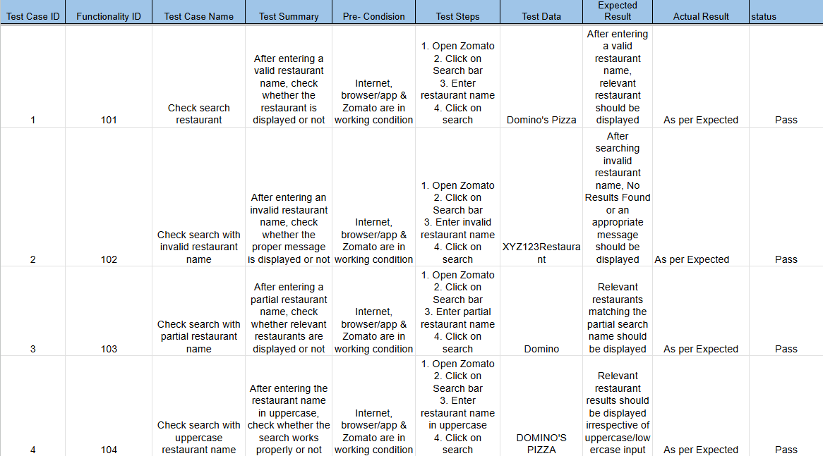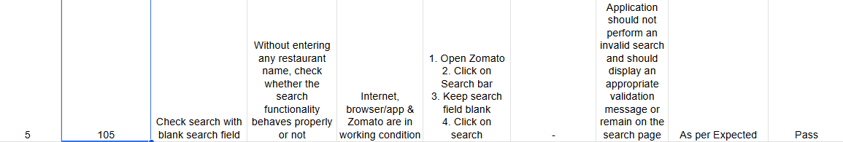

- Download or create a simple test case template in Excel or Google Sheets. Fill it with 4 test cases for the 'Add to Playlist' feature in a Spotify-like app, using the columns: Test Case ID, Scenario, Steps, Test Data, Expected Result.
Ans =>
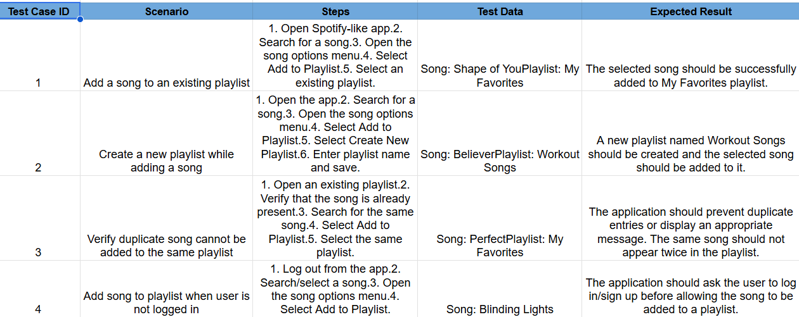

- Write a basic test script (in plain English, not code) for the 'Login with OTP' feature in a Paytm-style app, describing the exact steps a tester would follow to manually test the OTP flow from start to finish.<br><br><em><strong>Constraint:</strong> Include both valid and invalid OTP scenarios in your script.</em>
Ans =>
Test Script
Scenario 1: Login with Valid OTP
- Open the application.
- Navigate to the Login screen.
- Enter a valid registered mobile number.
- Click/tap Continue or Send OTP.
- Verify that an OTP is sent to the entered mobile number.
- Open the SMS received on the registered mobile number.
- Note the OTP.
- Enter the received OTP in the OTP field.
- Click/tap Verify OTP or Login.
- Verify that the OTP is accepted.
- Verify that the user is successfully logged in.
- Verify that the application redirects the user to the Home/Dashboard screen.
- Verify that the logged-in user's information is displayed correctly.

Scenario 2: Login with Invalid OTP
- Open the application.
- Navigate to the Login screen.
- Enter a valid registered mobile number.
- Click/tap Continue or Send OTP.
- Wait for the OTP to be received.
- Enter an incorrect OTP instead of the received OTP.
- Click/tap Verify OTP or Login.
- Verify the application response.

